Barton Area Action Plan Proposed Submission: Draft for Council, 19 December 2011
Example Illustrative Sections

Illustration 1

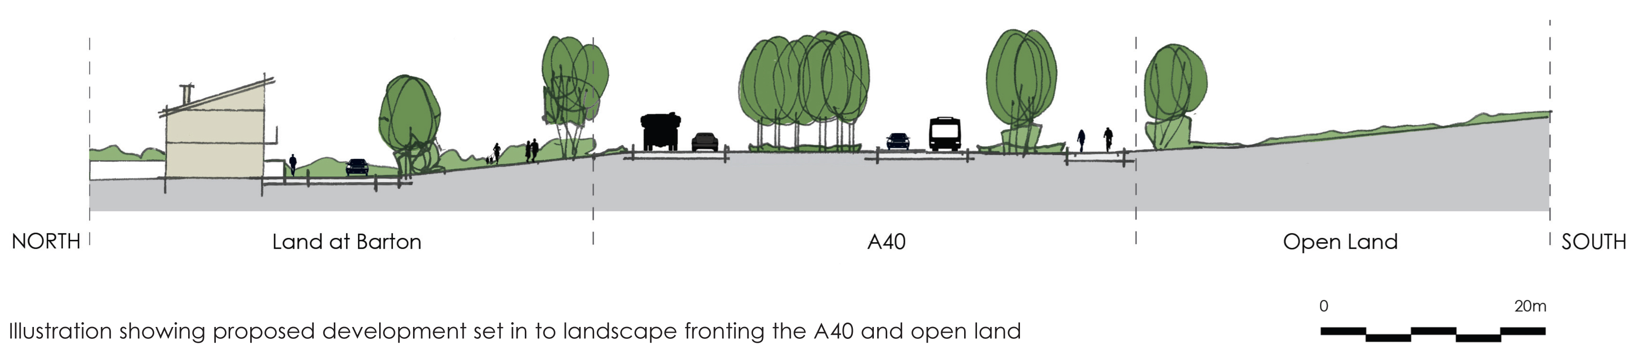

Illustration 3

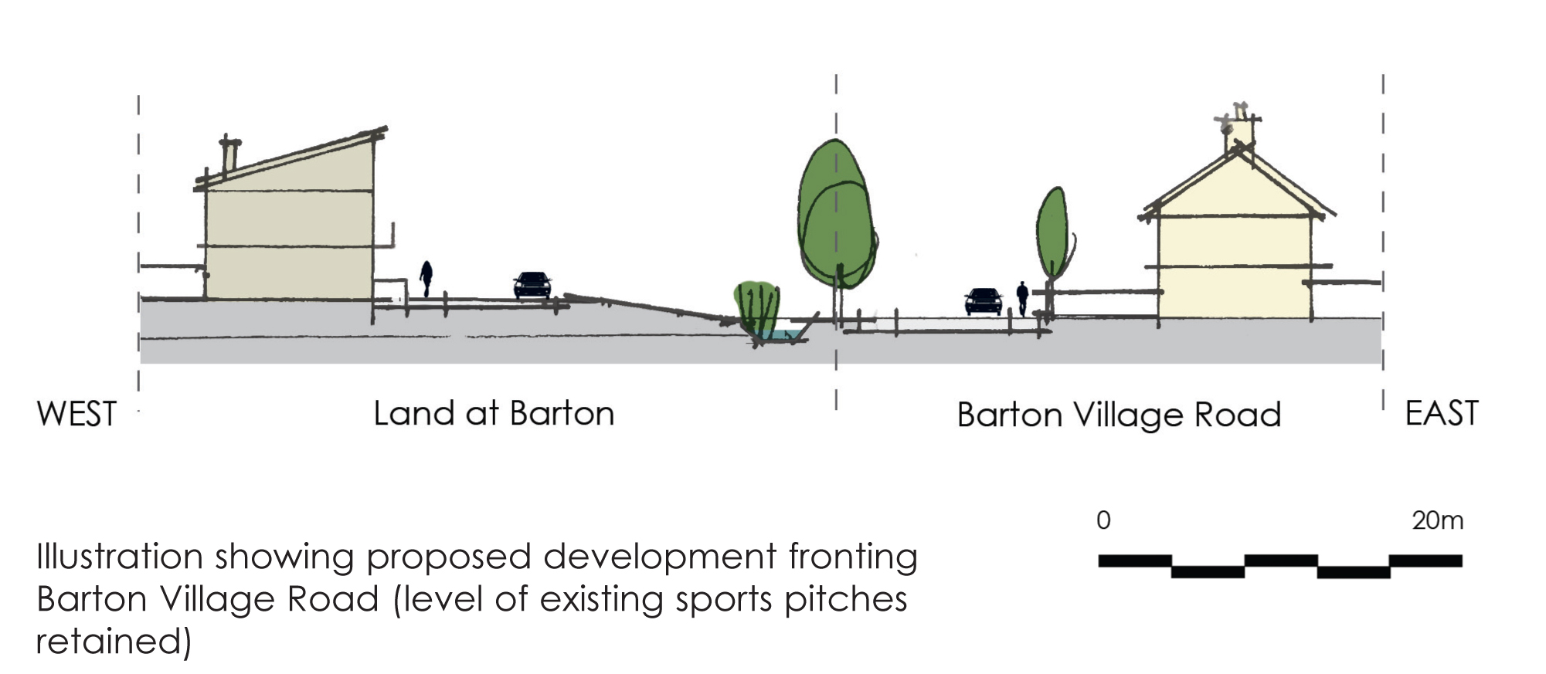

Illustration 5

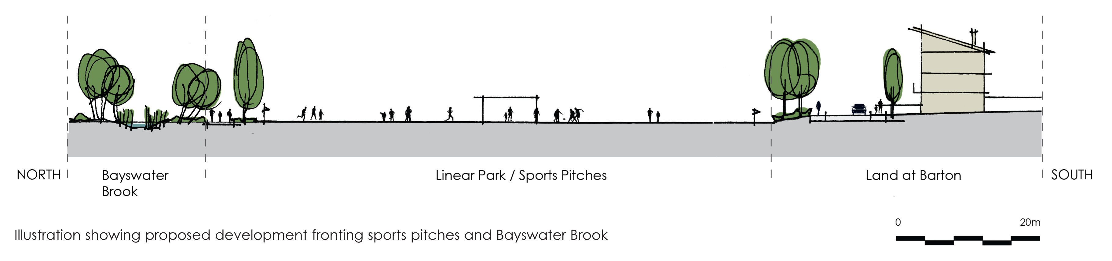

Illustration 7



